Voice Agent Debugger PRD
Nov 1, 2026 · @Daksh Khandelwal

Summary
We are building an open-source debugger for voice agents that proves why a call failed, fixes it and shows the fix held. Existing evals stop at a score. Ours ends with a named cause, a patch and a before-and-after pass rate.
The pitch: EVA tells you the agent scored 0.47. We tell you speech-to-text caused it, patch it, and prove nothing else broke.
The core invention is counterfactual replay. We re-run a failed call from the failing turn, replace one pipeline layer with a perfect version, and measure whether the outcome flips. Repeated trials separate real causes from noise.
Hackathon scope: one cascaded agent on Pipecat, one domain, 5–10 base scenarios, and a suite of seeded bugs that measures our own accuracy.
Assumptions: a 48-hour event and 3–4 builders. Targets in this document are proposed goals, not measured results.

Vision and problem
Vision: every voice agent failure becomes a proven cause, a tested fix and a permanent regression test, without a person listening to calls.
An eval is a measuring instrument. It must predict what real callers will experience and tell the team what to change. That depends on a chain, and each link can produce a false result.
Link | Question it must answer | State of the art | Our response
Scenarios | Are we testing failures that matter? | Often hand-written | Red-team mutations that hunt for failures
Simulated caller | Does it behave like a person? | Too clean, too patient | Scripted barge-ins, self-corrections and validity checks
Conversation | Is the setup realistic? | Mock tools, limited stress | Accept mocks for now, and state the limit
Judge | Would a human agree? | Strong on some metrics, weak on safety | Evidence checks, abstention and a labelled set
Score | Is it repeatable? | Handled well by EVA | Repeated trials on every claim
Action | What broke, and did the fix work? | Largely unsolved | The core of this product
The evidence shows why a score alone is not enough:
- Failure is normal. No system in EVA-Bench clears 0.5 on both accuracy and experience. Voice agents in τ-Voice complete 26–38% of tasks under realistic conditions.
- One run proves little. EVA reports a median gap of 0.44 between passing once and passing every time on accuracy.
- Task completion hides problems. In EVA, 72% of calls that completed the task still had a faithfulness deviation.
- Errors cascade across layers. EVA found key-entity transcription accuracy tracks task completion at r=0.93 across seven cascaded systems. A transcript-only review can blame the LLM for a speech-to-text error.
- Judges can miss what matters most. In the Sprinklr judge study, humans scored telecom safety events 3–6 times higher than LLM judges did.

Uniqueness
Our edge is causal evidence: we test a cause by intervening, where other tools infer it from a transcript. A simulated caller plus an AI judge is now the baseline, so we reuse that layer and compete above it.
Capability | EVA-Bench | τ-Voice | Commercial platforms | This product
Bot-to-bot audio simulation | Yes | Yes | Standard | Yes, reused
Repeated-trial reliability | Yes | Single-run pass rate | Varies | Yes, on every claim
Interruptions from the caller | Not systematic | Yes | Claimed by several | Scripted, at word level
Failure-driven scenario search | Hand-designed | Not described | Generation exists; failure-driven not found | Yes
Cause assigned to a layer | Diagnostic signals only | Not offered | Rare; SuperBryn claims it | Proven by intervention
Fix proposed and re-tested | Not offered | Not offered | Rare; SuperBryn claims it | Yes, with a regression gate
Judge abstains and defers to humans | Not offered | Not offered | Evalion has human review | Yes
Published accuracy of its own diagnosis | Not applicable | Not applicable | Not found | Yes, on seeded bugs
Three things together make this hard to copy quickly:
- Interventions, not opinions. Each cause carries a measured effect size from a controlled re-run.
- Ground truth from the simulator. The caller knows exactly what it said, and the tool database is deterministic. Those two facts make perfect-layer substitution possible.
- Self-measurement. We seed known bugs and publish a confusion matrix of our own diagnoses, which answers the question of why anyone should trust the tool.
Limit on this claim: commercial rows come from two vendor-written surveys, not hands-on testing. "Not found" means absent from those sources. Check competitors again before claiming a first on stage.

Users and goals
The primary user is the engineer who owns a cascaded voice agent and must decide what to change before the next release.
User | Job to be done | What they need from us
Voice agent engineer (primary) | Find why calls fail and fix the right layer | Named cause, evidence, patch and regression result
QA or conversation designer | Catch failures before release | Generated test cases and a readable pass or fail report
Engineering lead | Decide whether a release is safe | Pass rates with confidence, and calls awaiting human review
Hackathon judge | Decide whether this is novel and real | A live flip of a failed call, plus our accuracy on seeded bugs
Goals
- Name the responsible layer for a failed call, with measured evidence.
- Produce a patch that raises the pass rate without a detected regression.
- Turn every confirmed failure into a permanent test.
- Report how accurate our own diagnoses and judges are.
Non-goals for the hackathon
- Speech-to-speech agents: they expose no layers to swap, so only perturbation tests would apply.
- Production monitoring and real telephony: these are crowded categories and don't support the core claim.
- Real tool APIs: we use deterministic mock tools, which replay requires.
- Automatic deployment: a person approves every patch.
- A large metrics catalog: a small set of trusted metrics beats fifty unverified ones.
- Multi-language coverage: this is the strongest next step, but it needs native-speaker labels.

Functional requirements
The product is one loop of five stages: Find, Explain, Fix, Prove and Remember. P0 items must work for the demo, P1 items strengthen it, and P2 items are cut first.
ID | Stage | Requirement | Acceptance test | Priority
F1 | Foundation | Run a scenario over bot-to-bot audio against a Pipecat agent | A run produces audio, a transcript and a final database state | P0
F2 | Foundation | Record a complete, replayable trace for every turn | Any turn can be restored from the stored trace alone | P0
F3 | Foundation | Reject runs where the simulated caller broke its script | Seeded caller errors are labelled invalid, not agent failures | P0
F4 | Find | Mutate scenarios with red-team operators | At least 4 operators produce valid scenarios | P0
F5 | Find | Spend trials on the operators that find the most failures | A multi-armed bandit shifts trials toward productive operators | P1
F6 | Find | Trigger barge-ins at a chosen word in the agent's speech | Interruption lands within a set timing tolerance | P1
J1 | Judge | Score task success from a field-level database diff | Result names which fields are wrong | P0
J2 | Judge | LLM judges return a verdict, confidence and quoted evidence | Quotes that don't exist in the trace are rejected | P0
J3 | Judge | Send safety calls and judge disagreements to a human queue | Seeded ambiguous calls appear in the queue | P0
J4 | Judge | Report judge agreement with human labels | Cohen's κ shown per metric, with sample size | P0
E1 | Explain | Locate candidate failing turns | Top 3 candidates include the seeded turn | P0
E2 | Explain | Replay a turn with one layer replaced | All 5 interventions work on a recorded call | P0
E3 | Explain | Continue the call to its end after an intervention | Other layers remain real in the continuation | P0
E4 | Explain | Compare arms over repeated trials and return a verdict | Output is proven, likely, compound or inconclusive | P0
E5 | Explain | Test pairs of interventions when no single one works | A seeded two-layer bug returns compound | P1
X1 | Fix | Generate a patch suited to the proven cause | Each layer class has at least one patch type | P0
X2 | Fix | Show the patch as a reviewable diff | A person approves or rejects it before it is applied | P0
V1 | Prove | Re-test the patch on failing, held-out and regression scenarios | Report shows before and after rates for each set | P0
V2 | Prove | Confirm the winning patch in a full live audio run | Live result is stored beside offline results | P1
R1 | Remember | Save confirmed failures as permanent tests | The next suite run includes the new test | P0
U1 | Interface | Show the failing audio, cause, patch and results on one screen | A newcomer can state the cause in under 30 seconds | P0
U2 | Interface | Run the whole loop from a CLI with JSON output | A CI job can fail on a regression | P1
U3 | Interface | Export a shareable report | Report opens without the app running | P2

Technical design
The system depends on one property: any turn of any call can be restored and re-run with exactly one thing changed. Every design choice below protects that property.
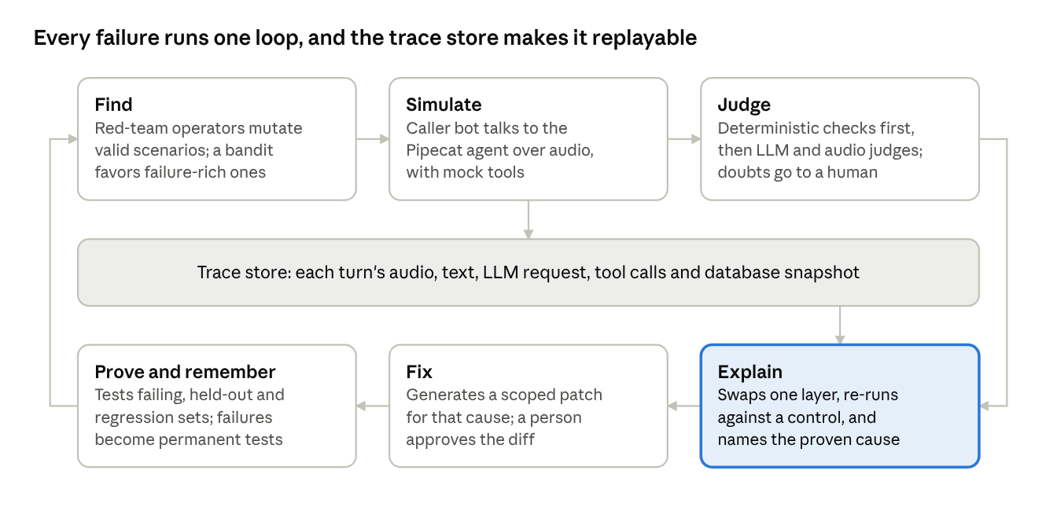
system architecture · 6 stages around a trace store
The simulator writes to the trace store, and Explain reads from it. That shared record is what makes a controlled re-run possible.

Stack
Part | Choice | Reason
Agent under test | Pipecat cascaded pipeline | Each layer is reachable, and EVA already supports it
Harness and scenarios | EVA where its license and structure allow | Avoids rebuilding the simulator, validators and metrics
Backend | Python, asyncio, FastAPI | Matches Pipecat, and handles concurrent trials
Storage | SQLite plus audio files on disk | Enough for a demo, and easy to reset
Interface | React with a waveform player | Clicking evidence jumps to the audio
Speech and model vendors | Pluggable by configuration | Vendors can be swapped if a key or rate limit fails

Trace: the replay contract
Each turn stores everything needed to restore it. If a field is missing, replay is not valid, so F2 is built first.
Layer | Stored per turn
Caller | Intended text, spoken audio, voice, operator applied, random seed
Endpointing | Speech start and end, interruption events, word timestamps
Speech-to-text | Final hypothesis, partial hypotheses, confidence, model and settings
LLM | Full request, model, temperature, seed, response, token timing
Tools | Calls, arguments, results, database hash before and after
Text-to-speech | Input text, normalized text, audio, word timestamps
The database is copied at each turn, so a replay starts from the exact state of that moment.

Counterfactual engine
The engine runs in four steps.
- Locate. Rank up to 3 candidate turns using entity mismatches between caller text and transcript, the first wrong tool call or database change, timing violations and turns cited by the judge.
- Triage. Replay only the candidate turn under each intervention. This is cheap, and an arm that doesn't change the turn is dropped.
- Continue. Run surviving arms and a control arm to the end of the call, repeated across trials.
- Decide. Compare final pass rates and issue a verdict.
The five interventions:
Layer tested | Intervention | Evidence that this layer caused it
Speech-to-text | Feed the caller's true words to the LLM | Pass rate recovers
Endpointing | Merge a fragmented utterance before the LLM sees it | Pass rate recovers
LLM or prompt | Swap in a stronger model, then test the same model with a corrected prompt | Stronger model recovers = capability; corrected prompt recovers = prompt
Tools | Supply the correct tool result, or correct invalid arguments | Pass rate recovers
Text-to-speech | Deliver the agent's intended text directly to the caller | Pass rate recovers, and an audio judge confirms the mismatch
A control arm re-runs from the same turn with no change. Without it, a rare failure would look fixed by any intervention.
Avoiding a false comparison. If continuations ran in text only, later speech errors would vanish from every arm, and every arm would look better. So non-intervened layers stay real after the swap: caller text goes through real text-to-speech and real speech-to-text.
Offline audio mode. Continuations run faster than real time by processing audio without waiting on a live clock. Text-to-speech results are cached by text and voice. Speech-to-text results are cached by audio hash and settings. LLM calls are not cached across trials, because that randomness is what we are measuring. Offline mode cannot measure latency, so V2 confirms the winner live.

Verdict statistics
Each verdict compares an intervention's pass rate with the control's. We start with 5 trials per arm and extend to 10 or more when the result is ambiguous.
- 5/5 against 0/5 gives a two-sided Fisher exact p of about 0.008.
- 4/5 against 1/5 gives about 0.21, which isn't enough, so that case extends.
- 8/10 against 2/10 gives about 0.02.
Verdict | Rule
Proven | Effect of at least 0.5, with p below 0.05 after correcting for the arms tested
Likely | Effect of at least 0.3, but significance is not reached within the trial budget
Compound | No single arm qualifies, but a pair does
Inconclusive | Nothing qualifies, and the interface says so plainly
Not the agent | The control arm passes consistently or the caller run is invalid
These thresholds are starting points. They get tuned once, on the seeded bug suite, and then frozen.
Cost per diagnosis: candidate turns × surviving arms × trials. One turn with 3 surviving arms and a control at 5 trials is 20 continuations. Triage and caching keep this manageable, so we should measure it in the first integration run.

Red-team search
The search uses mutation operators on valid scenarios, with the expected final database state preserved:
- Hard entities: alphanumeric codes, homophones, spelled-out names.
- Self-correction: the caller changes a detail after stating it.
- Barge-in: the caller interrupts at a chosen word, such as during a confirmation.
- Policy boundary: requests just outside what the agent may do.
- Intent switch: the caller changes goal mid-call.
- Acoustics: noise and accent perturbations.
Thompson sampling allocates trials across operators by failure yield. Every mutated run passes the caller-validity check before it counts, so simulator mistakes don't appear as agent failures.

Judges
Scoring follows a strict order, cheapest and most reliable first.
- Deterministic: field-level database diff, tool validity and timing rules.
- LLM text judges: faithfulness and conversation progression. Each returns a verdict, confidence and quoted evidence, and the quotes are checked against the trace.
- Audio judge: whether spoken audio matches intended text, especially on entities. EVA reports lower reliability for audio judges, so this supports a verdict and never decides one alone.
Two judges from different model families score each qualitative metric, because EVA flags bias when judge and agent share a family. Disagreement, low confidence or any safety flag sends the call to a human queue. Judge agreement is measured against 30–50 hand-labelled calls.

Patch generation
Each patch is restricted to changes suited to the proven cause, which prevents the LLM from rewriting everything.
Proven cause | Allowed patches
Speech-to-text | Keyword boosting, or a prompt rule to read back and confirm entities
Endpointing | Silence threshold and interruption settings
LLM or prompt | A scoped prompt rule or example; a model change if capability was the cause
Tools | Tighter argument schema, description or validation
Text-to-speech | Pronunciation dictionary and number or code formatting
A patch passes the gate only when all three hold:
- The failing scenario's pass rate improves significantly.
- Held-out variants, with different entities and wording, also improve. This catches a patch that only memorized the test.
- The regression suite shows no significant drop.

Core records
Record | Key fields
Scenario | Goal, persona, decision tree, initial and expected database state, parent, operator
Run | Scenario, agent config hash, seed, validity, status
Turn | Run, index, layer traces, database snapshot
Verdict | Run, metric, judge, score, confidence, evidence, review state
Experiment | Failing run, turn, arm, trials, pass count
Diagnosis | Run, cause, effect size, p-value, verdict
Patch | Diagnosis, diff, gate results, approval state

Success metrics and self-validation
The measure of success is whether the debugger identifies causes we planted without knowing the answer in advance. All targets below are proposed goals, to be replaced by measured values.
Metric | Definition | Proposed target
Attribution accuracy | Seeded bugs assigned to the correct layer | At least 80%
False blame rate | Healthy or caller-error calls blamed on a layer | At most 10%
Inconclusive rate | Seeded bugs returning no verdict | At most 20%
Fix success | Proven causes whose patch passes the full gate | At least 60%
Judge agreement | Cohen's κ against human labels, per metric | At least 0.6, reported honestly either way
Time to diagnosis | Failed call to verdict | Under 5 minutes
Cost per diagnosis | API spend per verdict | Measured and shown

Seeded bug suite
The suite is about 24 cases, each with a known answer, split between a tuning set and a blind test set. Thresholds are frozen on the tuning set, and only the blind set is reported.
Class | Example planted bug | Cases | Correct answer
Speech-to-text | Forced confusion of similar-sounding letters in a code | 4 | Speech-to-text
Endpointing | Aggressive silence threshold that splits an utterance | 3 | Endpointing
LLM or prompt | A policy line removed from the system prompt | 4 | LLM or prompt
Tools | Argument mapping that swaps two fields | 3 | Tools
Text-to-speech | Digit formatting that misreads a code aloud | 3 | Text-to-speech
Compound | Two planted bugs that must both be fixed | 2 | Compound
Caller error | A simulator that breaks its own script | 2 | Not the agent
Healthy | No bug planted | 3 | Not the agent
The output is a confusion matrix shown in the demo. A wrong answer on the matrix is better than a claim no one can check.
What this doesn't prove: planted bugs may be cleaner than real ones, so accuracy here is probably optimistic for real-world calls. Real calls remain untested at this stage.

Build plan and demo
Build the replay contract first and the interface last, because the whole product fails if replay fails.
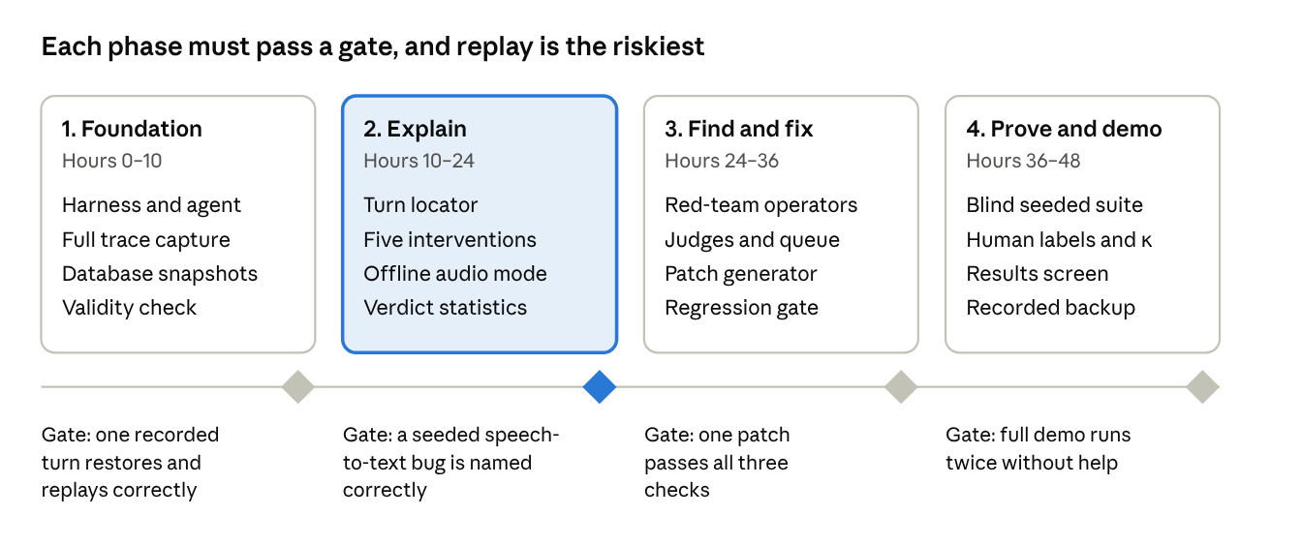
48-hour build plan · 4 phases, 4 gates
If gate 2 is missed by hour 24, cut red-team search and patches for two layers, and protect the Explain stage. Scope falls back to a working diagnosis on recorded failures.

Team split
Role | Owns
Harness engineer | Pipecat agent, trace capture, snapshots, offline audio mode
Causal engine engineer | Locator, interventions, statistics, seeded bug suite
Eval and judge engineer | Judges, red-team operators, human labels, patch generation
Product and demo owner | Results screen, narrative, recorded backup, pitch
With three people, the demo owner's work splits across the others, and the interface gets simpler.

Three-minute demo
- The failure (30 seconds). Play a call where the agent books the wrong confirmation code, though the transcript looks plausible.
- The gap (15 seconds). Show the single score, then ask, "Now what?"
- The proof (60 seconds). Run the interventions and show the speech-to-text arm recover while the other arms don't.
- The fix (30 seconds). Apply the patch, then show the failing, held-out and regression results.
- The trust (30 seconds). Show the confusion matrix, judge agreement and a safety call waiting for a human.
- The close (15 seconds). "Every failure becomes a proven cause, a tested fix and a permanent test."
Precompute the trials and record a backup run. Trigger one small replay live, so the audience sees that it is real. Report the actual numbers from the run, even if they differ from this script.

Risks and open questions
The largest risk is that replay doesn't reproduce the failure, so that is tested first, by hour 10.
Risk | Why it matters | Mitigation or fallback
Control arm doesn't reproduce the failure | Rare failures make every comparison weak | Select scenarios with high failure rates; report "Not the agent" otherwise
Trials are too few for significance | Weak evidence undermines the core claim | Sequential trials; plant strong bugs; show "likely" honestly
Offline mode behaves unlike live audio | Streaming and batch speech-to-text can differ | Feed the streaming API where possible; confirm winners live
Swaps change more than one thing | Swapping a model also changes style and later turns | Fix seeds and settings; describe results as recovery, not absolute proof
API cost or rate limits | Each diagnosis needs many continuations | Triage first, cache speech, keep 2 vendors ready
EVA is hard to extend, or its license blocks reuse | Could cost the first day | Check in hour 1; fall back to a minimal Pipecat harness and our own scenarios
Patch memorizes the test | Would produce a false success | Held-out variants are part of the gate
Judges are wrong on safety | Documented weakness of LLM judges | Safety flags always go to a human
A competitor already does this | Weakens the "first" claim | Pitch on published accuracy, which holds either way
Live demo fails | One failure can sink the pitch | Precomputed results and a recorded backup

Open questions
- ☐ What are the hackathon's actual length, team size, judging criteria and sponsor tracks?
- ☐ Does EVA's license and code structure allow the turn-level hooks we need?
- ☐ Which domain should we demo, based on which EVA scenarios fail most often on our agent?
- ☐ Do our speech-to-text vendors allow streaming faster than real time?
- ☐ Who will hand-label the 30–50 calls, and when?

After the hackathon
- Replay real production calls by building traces from logged audio.
- Add regional languages and code-switching as a test matrix.
- Calibrate the simulated caller against real call behavior.
- Support speech-to-speech agents through perturbation tests.

Sources
Some of these papers were read partly through extracted summaries, including EVA's judge agreement details. Verify any figure before quoting it on stage. EVA's regeneration rate appeared with conflicting values, so this document doesn't cite it.
- EVA-Bench paper (arXiv 2605.13841)
- ServiceNow EVA repository
- τ-Voice (arXiv 2603.13686)
- LLM judges for voice-agent evaluation (arXiv 2608.24314)
- Testing the Testers (arXiv 2511.04133)
- Speechmatics platform survey, vendor-written
- ContextQA tool comparison, vendor-written

